|  |  |  |  |
| --- | --- | --- | --- |
| NAME: | Georelle Ila, Joshua Sarcol | DATE: | 11/19/2023 |

PRACTICE EXERCISE # 7.1

# LE 7_11 Largest and Smallest

Design the logic for a program that allows a user to enter 10 numbers, then displays all of the numbers, the largest number, and the smallest.

## Pseudocode: LE 7_11 Largest and Smallest

main()

START

1. INITIALIZE list as array of integers
2. FOR i = 0 to 10 exclusive by 1
   1. PROMPT and GET list[i]
3. ENDFOR
4. CALL module, largest = largestInList(list)
5. CALL module, smallest = smallestInList(list)
6. FOR i = 0 to 10 exclusive by 1
   1. PRINT list[i]
7. ENDFOR
8. PRINT largest and smallest

STOP

largestInList(arr[])

1. INITIALIZE result as arr[0]
2. FOR i = 1 to 10 exclusive by 1
   1. IF result < arr[i]
      1. SET result as arr[i]
   2. ENDIF
3. ENDFOR

RETURN result

smallestInList(arr[])

1. INITIALIZE result as arr[0]
2. FOR i = 1 to 10 exclusive by 1
   1. IF result > arr[i]
      1. SET result as arr[i]
   2. ENDIF
3. ENDFOR

RETURN result

## Flowchart: LE 7_11 Largest and Smallest

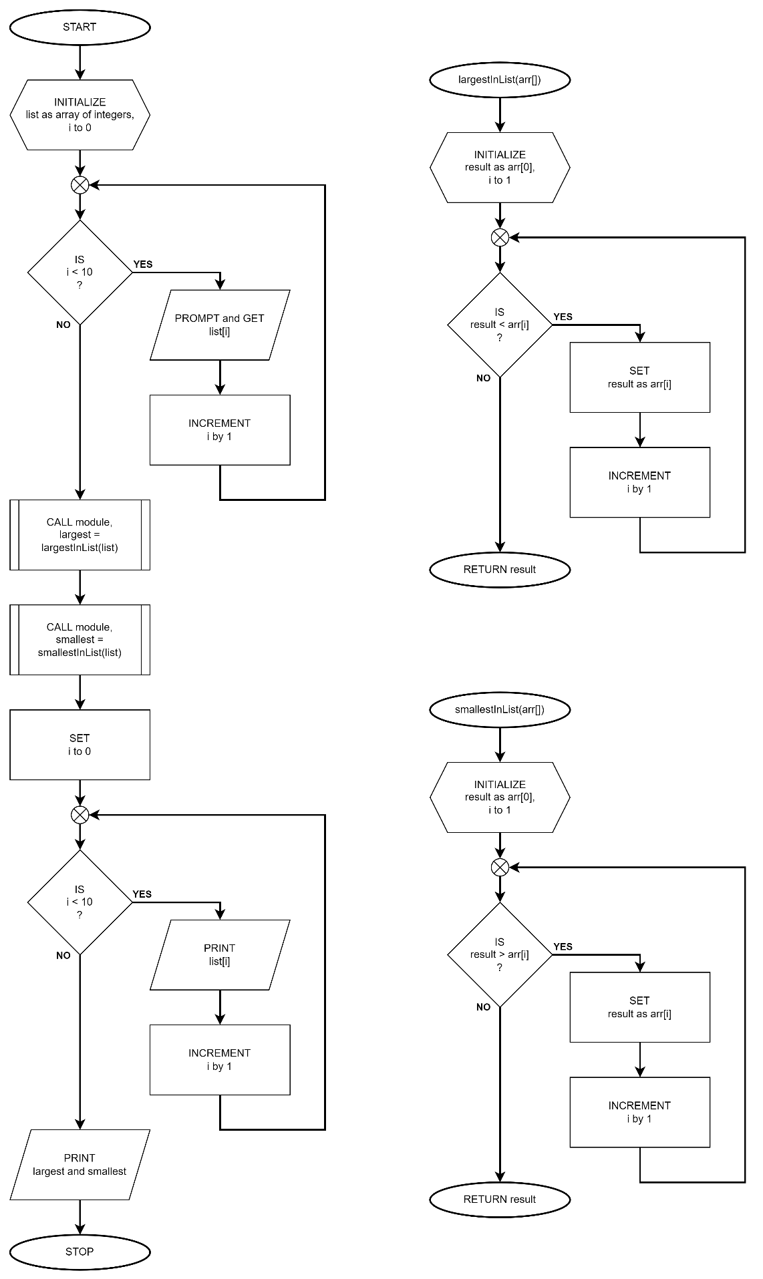

# LE 7_12 Vowels and Consonants in String

Ask a string and determine how many vowels and consonants.

## Psuedocode: Vowels and Consonants in String

main()

START

1. INITIALIZE word as array of characters
2. PROMPT and GET word
3. CALL module, vowels = vowelCount(word)
4. CALL module, consonants = consonantCount(word)
5. PRINT vowels and consonants

STOP

vowelCount(arr[])

START

1. INITIALIZE result to 0
2. FOR i = 0 to length of arr exclusive by 1
   1. IF arr[i] is a letter and a vowel
      1. INCREMENT result by 1
   2. ENDIF
3. ENDFOR

RETURN result

consonantCount(arr[])

START

1. INITIALIZE result to 0
2. FOR i = 0 to length of arr exclusive by 1
   1. IF arr[i] is a letter and not a vowel
      1. INCREMENT result by 1
   2. ENDIF
3. ENDFOR

RETURN result

## Flowchart: Vowels and Consonants in String

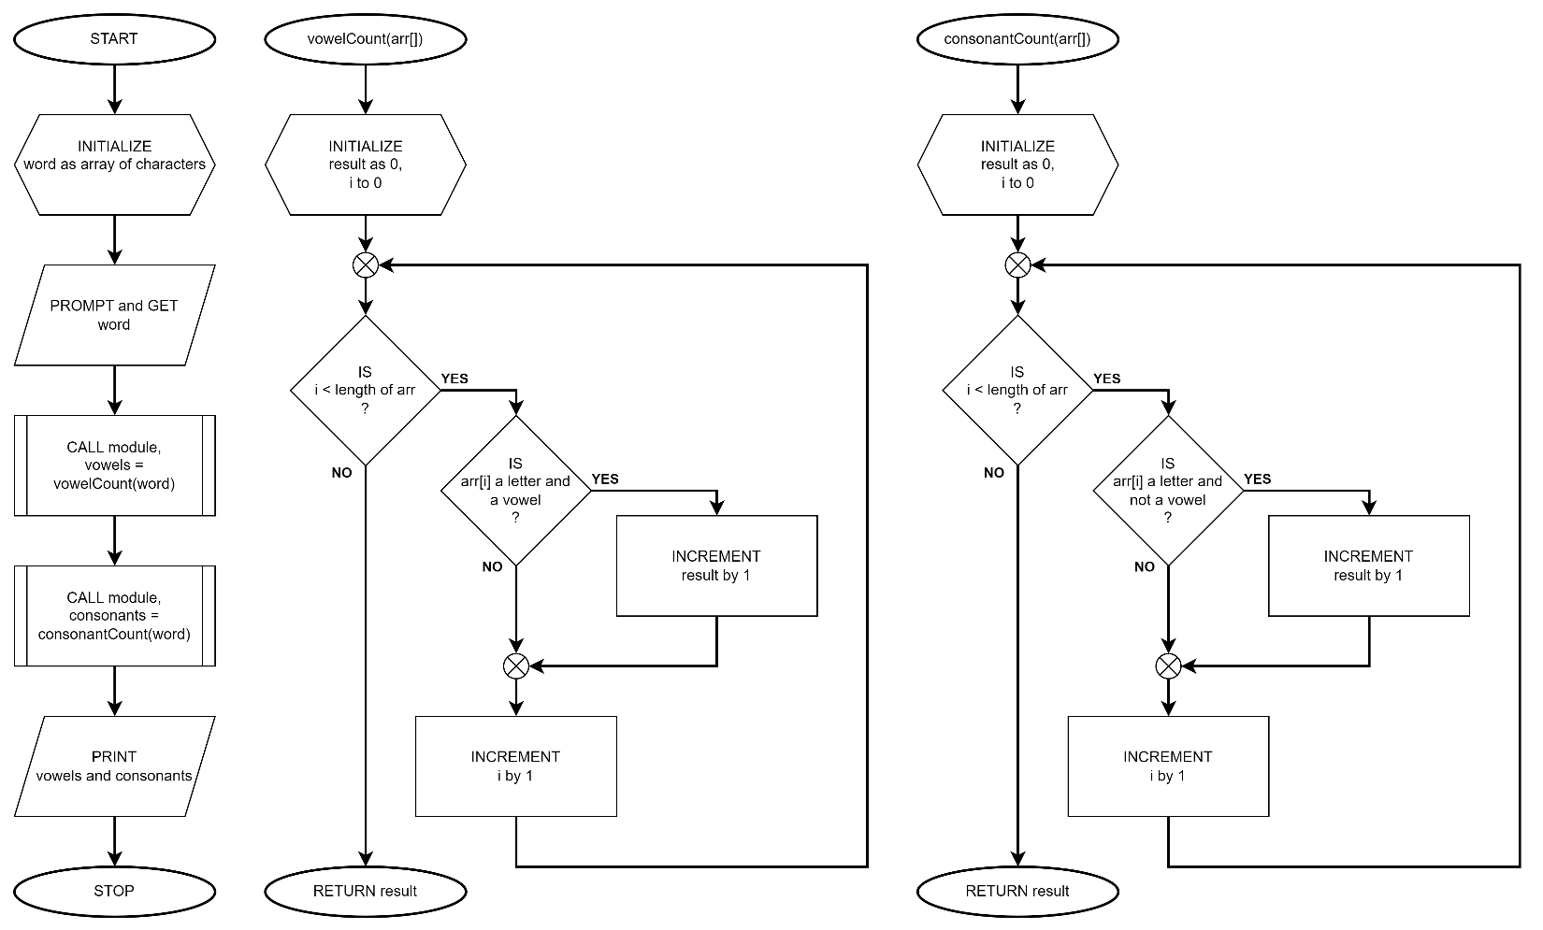

# LE 7_13 Longest String

Ask for 5 strings and display the longest string.

## Psuedocode: LE 7_13 Longest String

main()

START

1. INITIALIZE words as two-dimensional array of characters of size [5][100]
2. FOR i = 0 to 5 exclusive by 1
   1. PROMPT and GET words[i]
3. ENDFOR
4. CALL module, longestWord = words[longestString(words)]
5. PRINT longestWord

STOP

longestString(arr[][])

START

1. INITIALIZE length as length of arr[0] and result as 0
2. FOR i = 1 to 5 exclusive by 1
   1. IF length < length of arr[i]
      1. SET length as length of arr[i]
      2. SET result as i
   2. ENDIF
3. ENDFOR

RETURN result

## Flowchart: LE 7_13 Longest String

